**BLUE EYES TECHNOLOGY**

**BY**

**KELVIN BASSEY IBRAHIM**

**ST/CS/ND/19/205**

**A SEMINAR PRESENTED TO THE DEPARTMENT OF COMPUTER SCIENCE, SCHOOL OF SCIENCE AND TECHNOLOGY, FEDERAL POLYTECHNIC MUBI, ADAMAWA STATE, NIGERIA**

**NOVEMBER,2021**

**BLUE EYES TECHNOLOGY**

**BY**

**KELVIN BASSEY IBRAHIM**

**ST/CS/ND/19/205**

**A SEMINAR PRESENTED TO THE DEPARTMENT OF COMPUTER SCIENCE, SCHOOL OF SCIENCE AND TECHNOLOGY, FEDERAL POLYTECHNIC MUBI, ADAMAWA STATE, NIGERIA**

**IN PARTIAL FULFILLMENT OF THE REQUIREMENTS FOR THE AWARD OF HIGHER NATIONAL DIPLOMA(HND)NATIONAL,DIPLOMA(ND) IN COMPUTER SCIENCE**

**NOVEMBER,2021**

***Abstract***

*The scientific world cannot be measured in terms of development and progress. It shows how far the human mind can work and think. We have now come to the technology known as "Blue eyes technology" which can sense and control people's emotions and feelings through gadgets. Eyes, fingers, speech are factors that help to sense the emotional state of the human body. After identifying the mood, songs will be played to make the person's emotional level normal.*

**INTRODUCTION**

Imagine being in a world where people are communicating with computers. You are sitting in front of a personal computer that can hear, talk, or shout loudly. It has the ability to gather information about you and engage you with special techniques such as facial recognition, speech recognition, etc. It can even sense your feelings by touching the mouse. It confirms your identity, hears your gifts, and starts communicating with you .You ask the computer to call your friend in his office. It detects the urgency of the situation with a mouse, calls your friend to his office, and establishes a connection. The app will allow them to interact as human beings, see people's gifts, talk, listen, or guess their feelings.

Suvam,C(2009) “Aims to create technologies of blue eyes with the ability to see and feel like those of humans”. It uses an unobstructed sensor system, uses many modern video cameras and microphones to detect users' actions using sensory transmission capabilities. The system can understand what the user wants, where he is looking, and even see his or her physical or emotional.

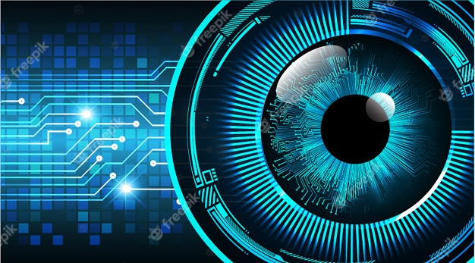

Figure: blue eyes technology

**SYSTEM REVIEW**

The blue eye system monitors the user's visual attention by measuring saccadic activity. The system checks parameters such as heart rate and blood pressure levels against abnormalities and activates user-defined alarms. The Blue Eyes system consists of a portable measuring device and a centralized analysis system. The mobile device is integrated with a Bluetooth module that provides wireless operation between the operator's sensors and the central unit. Amir and Adriana(2010) “Identity cards issued to each operator and sufficient user profiles” on the side of the central unit provide customization data required for system integration.

i. Mobile Measurement Device (DAU)

ii. Central System Unit (CSU)

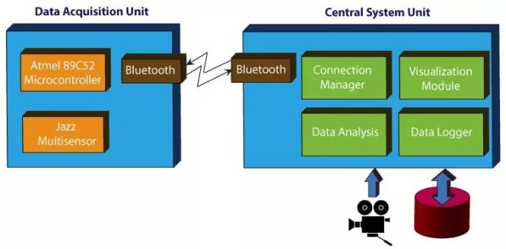

Figure: system overview

**WHAT IS BLUE EYES TECHNOLOGY?**

The purpose of creating this program is to have the ability to see and feel. Use the camera and microphone to detect user actions and emotions Blue Eyes - Bluetooth technology and eye movement. Bluetooth provides a reliable wireless connection. As eye movements enable us to acquire many interesting and valuable information.

**BENEFITS OF BLUE EYES TECHNOLOGY**

Mark(2001).Human error is still one of the most common causes of all humanitarian disasters. Today the human contribution to the overall functionality of the system has been left unattended. As the system is activated automatically, the operator becomes an inactive viewer of the monitored system, resulting in a decrease in awareness. It is therefore important to ensure that the user’s alert brain is involved in a functional program that will guide throughout the work. It is possible to indirectly measure the level of involvement of the user's brain using optical eye analysis. In large control rooms, plugging the operator into a central system is a serious limitation of his mobility and impairs his performance. A wireless link between the operator's sensor and the surveillance system provides a new way of complete reliability and security of the system.

i. Build a machine that can understand your emotions

ii. A computer that can listen, speak or shout

iii. Verify your identity, feel your presence and connect with you

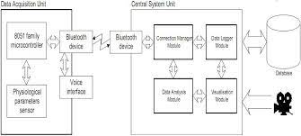

Figure: system review

**TECHNOLOGIES USED**

1. Emotion Mouse
2. Artificial Intelligent Speech Recognition
3. The eye movement Sensor

**Emotion Mouse:**

Jake(2008) This emotional mouse are clearly defined in a computer program mouse, with a precise pattern of human hands giving the reason for the six basic senses. This emotional mouse can be likened to the following by heart rate, body temperature, electrical stimulation of the skin, and other sensory features.

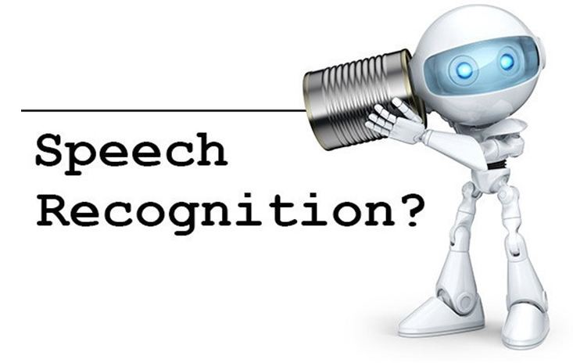

Figure: Artificial Intelligent Speech Recognition

**Artificial Intelligent Speech Recognition**

It is important to consider the area in which the speech recognition system should operate. Sound level, volume, microphone, and The speed of user speech can affect the quality of speech recognition. (Mcdonal,2013)."Welcome to company X. Please give me the extension number you want". You specify an extension number, your name, and the name of the person you want to contact

**Three basic ideas on why Artificial intelligence (AI) was introduced,**

i. Read the human mind.

ii. Represents the human thinking process with robots, computers, etc.

iii. The pilot gives instructions to the computers by speaking into the microphone

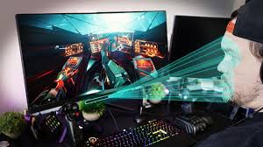

Figure**: eye movement sensor**

**THE EYE MOVEMENT SENSOR**

Eye movement is the process of measuring a person's visual area (where a person is looking) or eye-related eye movements. Eye tracker is a tool for measuring eye movements and eye movements. Eye trackers are used in visual system research in psychological science, psychological language and product design. There are several ways to measure eye movements. The most popular alternative to use.

**ADAVANTAGE AND DISADVANTAGE**

**Advantages**

1. This blue eyes technology is used for the Prevention from dangerous incidents.
2. It is used to monitors the Physiological condition.

**Disadvantages**

1. Doesn’t predict nor interfere with operator’s thoughts.
2. We cannot force the operator to work directly in the blue eyes technology.

**CONCLUSION**

The BLUE EYES technology ensures an easy way to simplify life by providing sophisticated and easy-to-use computer equipment. Now that we have verified the method, the next step is to upgrade the hardware. In the future we can expect more because of these factors, and it is very important and useful for this generation of people. It may access your mobile device manually. Either way this is a technical prediction only. The Blue Eyes system is being developed due to the need for a real-time monitoring system on a human operator.

**RECOMMATION**

Instead of using other tools to collect information about the user, it would be better to use smaller and seamless units. The day is not far spent when this technology will enter your home, making you lazy. It may access your mobile device manually. Either way this is a technical prediction only.

1. Researchers are trying to add to the complexity of computer systems that allow them to interact with other people,
2. see people's gifts, talk, listen, or guess their feelings.
3. Blue Eyes emphasizes the foundations of the project - Bluetooth technology and eye movement.

**REFERENCES**

Suvam,C(2009) “Aims to create technologies of blue eyes with the ability to see and feel like those of humans. *Journal of Head Master of Science Thesis Stockholm Sweden, 03(09).*

Amir,A. Adriana,M. (2010) “Identity cards issued to each operator and sufficient user profiles. *International Journal of Advanced Computer Science And Applications,05(01).*

Mark,M. (2001).Human error is still one of the most common causes of all humanitarian disasters. *Internal Conference Journal of Control,Automation Robotics And Vision Guangzhou,03(01)*

Jake,J. (2008) This emotional mouse are clearly defined in a computer program mouse. *Online Collaborative Approach for Sensor Data Management,07(08)*

Mcdonal,A. (2013) The speed of user speech can affect the quality of speech recognition. *Journal of Computing Techniques And Application International Conference, 04(13).*

Madhumitha,S. (2010) Blue Eyes Technology. *Journal of Psychologist World,01(10).*